Computer Workshop 4: Diagnosing linear models with a continuous predictor
Roos & Pinard
Last updated: 2024-08-18
Table of Contents

Workshop Structure
As always, we are using the workflow below to structure the workshops:
- Formulate a research question.
- Perform exploratory data analysis.
- Identify any hidden assumptions.
- Fit an appropriate model.
- Diagnose the model and check assumptions [Focus of today].
- Summarise the results.
- Interpret and provide inferences.
To keep the workload manageable for this workshop, we’ll be using the models you created in Workshop 3. For this session, either copy and paste your workflow from the previous workshop into a new script, or continue working with your existing script(s) from Workshop 2.
If you didn’t manage to finish Workshop 2, please do so now before moving on to diagnosing your model.

The Problem with Stats
Let’s start with the boto dolphin model we ran in the last workshop. Having fitted the model, we now have the equation with estimated parameters:
$$length_{i}∼\text{Normal}\left(μ_{i},σ\right)$$
$$μ_{i}=213.2+−5.3×drought_{i}$$
We used this derived equation to generate a figure:
But how do we know if we can trust this result? How do we know we haven’t been cursed by the Monkey’s Paw?
The bad news is that we can’t confirm it with absolute certainty. These results might be completely unreliable. The reason could be that the data is fatally flawed (i.e., we have unknowingly violated one of the hidden assumptions when using this dataset), or the model might not be suitable. The really bad news is that we almost always get an answer even when the data or model are violating assumptions.
This means it’s up to us to check for any signs that we shouldn’t trust the model results. It’s worth repeating, because it’s really important: we are trying to find any evidence that suggests the model results should not be interpreted. This is especially crucial in cases where your model could impact the real world. We don’t want to run a model that says a drug is completely safe, only to discover later that it has horrendous side effects.
The next bit of bad news is that the assumptions we care most about can’t be directly tested. It’s really hard, and sometimes impossible, to know if a dataset and corresponding model have violated the assumptions of validity and representativeness, despite these being the two most critical assumptions. In contrast, the assumptions we care least about tend to be the easiest to test. That’s not to say they aren’t important or worth diagnosing — they are. It’s just that the assumptions we care most about require more effort and insight. That’s why exploratory data analysis (EDA) and carefully considering these assumptions before we get to the modelling are so important. That’s why you should spend the majority of your time doing EDA and thinking about the data.
That said, we still want to check any assumptions we can. So how do we do it? In today’s workshop, we’ll focus on residuals. Remember, a “residual” is just the difference between a prediction and reality. To start, we need a model. Run your code from the last workshop, including the boto model (boto_model <- lm(length ~ drought, data = boto)).
As an additional step, which we’ll explain in more detail soon, we’ll also use the original data to see how long the model predicts each of our dolphins to be. To do this, we will use the predict() function, introduced in the last workshop. The key difference here is that we will use the actual dataset for predictions rather than a fake dataset. Conveniently, when we do this, we don’t have to specify the dataset explicitly. The model will use the same one for predictions that it used for fitting the model.
boto$predicted <- predict(boto_model)

Diagnosing
We’re now ready to perform some diagnostics. The code to fo this is relatively straightforward: you just need to plot() the model. Pay close attention to your R console when you do this. You’ll see a prompt that says Hit <Return> to see next plot:. If you press Return (or Enter) on your keyboard four times, you’ll see a total of four plots. Alternatively, you can “partition” you figure into two rows and two columns by doing:
par(mfrow = c(2,2)) # split figure into a 2 x 2
plot(boto_model)
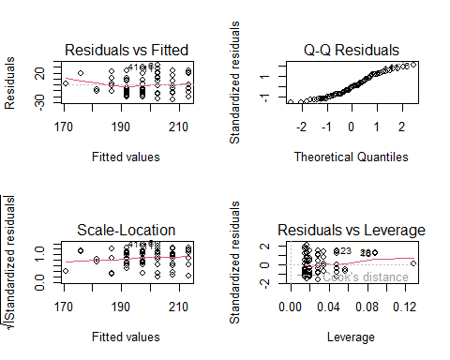
par(mfrow = c(1,1)) # reset to 1 x 1
Let’s go through these one at a time to understand what they’re telling us about our boto_model, whether they suggest any issues, and if there are issues, whether or not we should be concerned.

Residuals vs Fitted
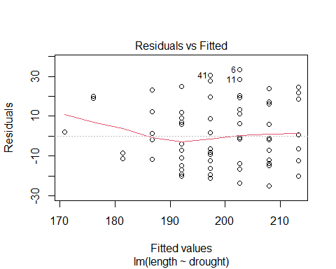
On the y-axis, we have the residual errors. In this case, these represent the difference between the actual measured length of a particular boto dolphin and what the model predicts. When a prediction is “perfect,” this difference will be zero, as indicated by the flat dashed line at a residual of zero.
The x-axis represents the length of the boto dolphins as predicted by the model. So, at the far left, we have a boto dolphin that the model predicts to be about 170 cm, and the corresponding residual is very close to zero — meaning the model was pretty accurate for this particular dolphin.
At the other extreme, there are a few points with numbers next to them. These numbers refer to the row numbers for the observations of those dolphins. For example, the point with a 6 next to it represents:
boto[6,]
Dolphin “6” is a male that had experienced two droughts and was 236 cm long but the model thinks it should be 203 cm long. If we wanted to, we could include an additional column in the boto dataset that calculates the residual error fairly easily:
boto$residual <- boto$length - boto$predicted
Now when we pull up dolphin “6”, we see:
boto[6,]
Dolphin “6” was 33 cm longer than the model thinks it should be.
So that’s where the residual values come from in this figure:
But what should we look for in this figure? Several assumptions might become apparent here.

Linearity
One of the key assumptions we examine is Linearity, which is one of the more important assumption we generally care about. (It’s often combined with additivity because they share similar properties and consequences.) For the linearity assumption, if the residuals display any kind of “wavy” pattern, it suggests that drawing a straight line through them isn’t capturing the relationship well, or that the relationship is not linear. For example, here’s a simulated dataset that clearly violates the linearity assumption:
df <- data.frame(x = 0:100)
df$y <- rnorm(n = nrow(df), mean = 0 + 2.5 * df$x + 0.05 * df$x^2 + -0.003 * df$x^3, sd = 100)
ggplot(df, aes(x = x, y = y)) +
geom_point() +
geom_smooth(method = "lm", se = F) +
labs(x = "Explanatory variable",
y = "Response variable") +
theme_minimal()
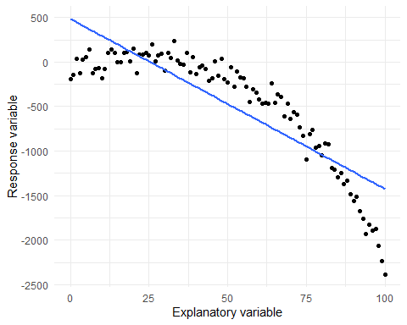
Based on the raw data (the points), we can see that the relationship appears fairly flat until the “Explanatory variable” (whatever that might be) reaches around 50, after which it begins to decline. The blue line represents the linear model fit to the data, where we’re trying to use a straight line to describe the trend in the points. In this example, when the explanatory variable is less than roughly 25, the model tends to overpredict (resulting in negative residuals). Beyond that point, the residuals become positive, and then negative again as the explanatory variable increases further. Here’s what the diagnostic plot for this model would look like:
m1 <- lm(y ~ x, data = df)
plot(m1, which = 1)
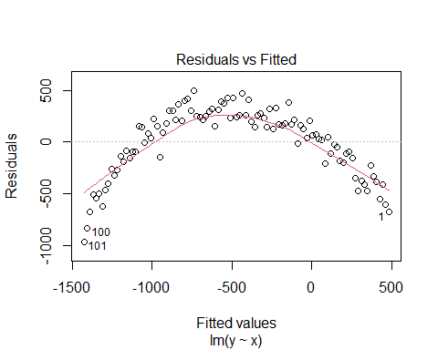
See the problem and how this plot helps us to see if the Linearity assumption is met in our model?
Violating the Linearity assumption can pretty dramatically impact the usefulness of our model, but in other cases, the impact can be minimal. For instance, in the lectures, we discussed a model where we related sea surface temperature to CO2 levels, which had a non-linear relationship. Even though we fitted a linear model to this non-linear data, our inference remained correct: “as CO2 increases, sea surface temperature increases.” However, in the above example, fitting a linear relationship across the explanatory variable values misleads us; The true relationship is relatively flat from 0 to 50 and only begins to decline after 50. If we incorrectly assume that $y$ always declines as $x$ increases, we would be misled for half of the $x$ values.
Ultimately, the severity of violating the Linearity assumption depends on the nature of the relationship. Sometimes breaking this assumption is acceptable; other times, it can be significantly problematic. The only way to determine the impact is to examine the data, the relationship estimated by the model, and to think about the context carefully.

Equal Variance of Errors
Similarly, we need to check if our residuals are equally spread across all the predicted lengths. Using another simulated dataset, here’s what that looks like:
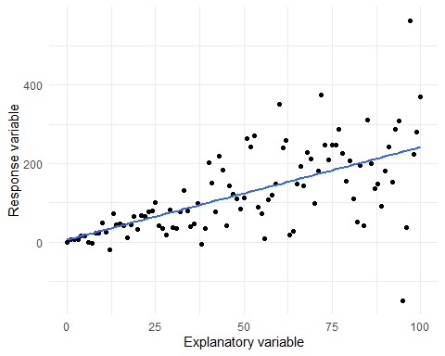
Notice that as the explanatory variable increases from zero to 100, there seems to be more and more variation? Well, we can see that clearly in the corresponding Fitted vs Residuals plot:
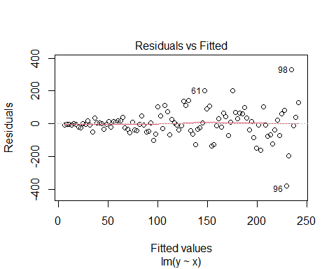
We have highly accurate predictions at the left side of the figure and comparatively inaccurate predictions to the right. Keep in mind that when fitting a linear model, we assume that the variation in residuals is constant across the range of predicted values. In the example above, this assumption is clearly being violated.
The consequence of violating the Equal Variance of Errors assumption is generally less severe than violating the Linearity assumption. It results in inflated standard errors for the parameters, though the parameters themselves are rarely biased. If our main goal in running a model is to just estimate the parameters, this assumption isn’t particularly critical. However, it becomes a problem if we need to account for or appreciate uncertainty (which we will cover next week) or if we are using Null Hypothesis Significance Testing (NHST) and P-values (which we will discuss in the last week of the course).
The important point is to consider whether breaking this assumption is a significant concern for your analysis. If you are not using P-values and you’re not terribly concerned about uncertainty, then break this assumption may not be a major issue.

Scale-Location
For the most part, the Scale-Location plot is similar to the Residuals vs Fitted plot. The key difference is that the y-axis does not represent the “pure” residuals but rather a transformed version of them. Specifically, the residuals are transformed by taking the square root of their absolute values (“absolute” means “all positive”).
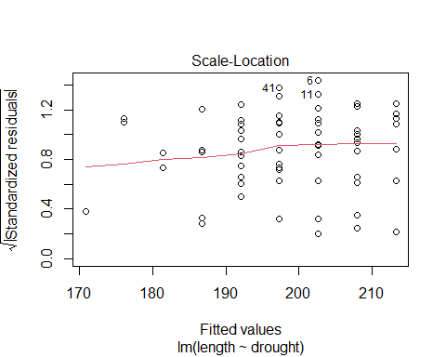
This means that the Scale-Location plot provides another opportunity to check the same assumptions that the Residuals vs Fitted plot did. The reason for having both plots is that sometimes one plot may make diagnosing issues easier than the other. For example, I often find the Scale-Location plot more useful for complex models but somewhat redundant for simpler ones. Indeed, there are times when the Residuals vs Fitted plot may appear problematic, but the checking Scale-Location plot can tell me that the issues are not as severe as they initially seemed.

Q-Q Residuals
The Q-Q plot is perhaps the least useful of the diagnostic plots or, alternatively, only useful in very specific circumstances. However, it’s important to understand when it is useful so that we know when to pay attention to it.

Normality of Errors
Predicting individual observations can be challenging. For instance, predicting the exact length of each individual boto dolphin is difficult. We don’t expect the model to be perfect, but we do want it to be reasonably accurate in its predictions, right? Well, sort of.
The normality of residuals is an assumption we check to ensure that the errors of our model (i.e., the differences between observed and predicted values) are normally distributed. In practice, this really means “how well can our model predict individual observations in our dataset?”. As a result minor, or sometimes even major, deviations from normality are acceptable. When we do see major deviations, this can suggest that the model is missing important explanatory variable to accurately predict each observation.
Here’s the crux. If you want to understand how drought impacts botos, then do you really care about how accurately you can predict each dolphin? Not really. Of course you’re not going to explain it perfectly. Would we really expect the only thing that impacts a dolphins length is how many years of drought it had experienced?
Regardless, the Q-Q plot helps us assess this assumption by comparing the distribution of the residuals to am “idealised” normal distribution. If the residuals follow a straight line in the Q-Q plot, this suggests they are approximately normally distributed.
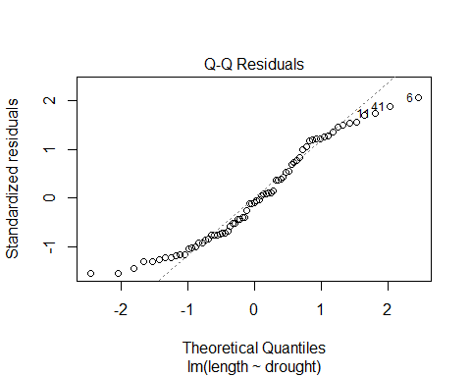
Another, and more complex, way to visualize the normality of residuals is shown in the next plot (the code will be provided in the answers but we’re not expecting you to recreate it - the code’s there just if you’re interested).
# Get residuals from the model
residuals <- residuals(boto_model)
# Get mean and SD for dnorm()/theoretical Normal
mean_residuals <- mean(residuals)
sd_residuals <- sd(residuals)
# Slap in a dataframe
residuals_df <- data.frame(residuals = residuals)
theoretical_df <- data.frame(
x = seq(min(residuals), max(residuals), length.out = 100)
)
# Get the "idealised" Normal distribution
theoretical_df$y <- dnorm(theoretical_df$x, mean = mean_residuals, sd = sd_residuals)
# Plot
ggplot() +
geom_histogram(data = residuals_df, aes(x = residuals, y = ..density..), binwidth = 3, fill = "lightgrey", color = "grey") +
geom_area(data = theoretical_df, aes(x = x, y = y), color = "black", fill = "#4AB54A", alpha = 0.3) +
labs(x = "Residuals",
y = "Density") +
theme_minimal()
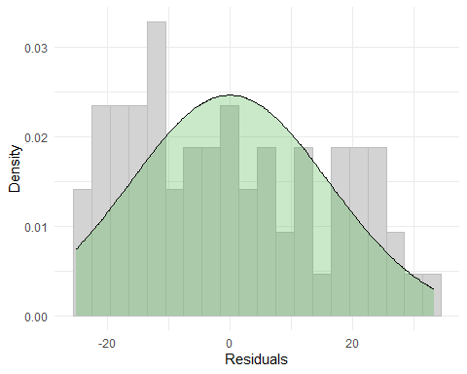
In the above figure, the residual errors are shown as a histogram, with the black line and green area representing the theoretical Normal distribution we expect. To me, this visualisation helps explain what the Q-Q plot is trying to show. Ideally, if the model were “perfect,” the grey bars would align perfectly with the green shaded area, with no bars extending beyond it. In our boto model, however, the bars tend to be slightly too tall on both the left and right sides but are about right in the middle.
Going back to the Q-Q plot, you can see the same thing:
In both versions of this figure, we observe deviations from what we’d expect if the distribution were “perfect,” particularly at the tails.
So what does this mean for our model? Are these deviations serious? Not really. While we ideally want our residuals to follow a Normal distribution, this only indicates how well our model predicts the observations in our dataset. It doesn’t confirm if the model is “right” or “wrong”; it merely assesses whether the model predicts the data accurately according to one particular method.
In most cases, a quick glance at the Q-Q plot is sufficient. If it looks particularly problematic, you might need to reconsider your model. However, if it appears only mildly off, it’s generally not a major issue. This is why Normality of Errors is considered less critical compared to other assumptions.

Residuals vs Leverage
The last plot doesn’t assess the assumptions we’ve discussed but provides a different kind of insight. It helps identify disproportionately influential data points.
If you need a refresher on what constitutes an “influential data point,” go to the lecture material from Wednesday.
In this plot, we look for observations that are close to a Cook’s distance of 1.
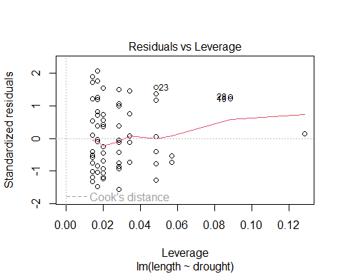
If you want an alternative way to check Cook’s distance, without showing Leverage, then you can do:
plot(boto_model, which = 4)
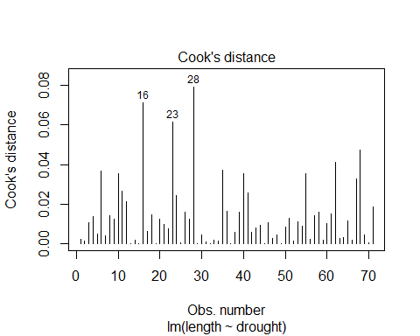
None of our points are close to 1, so we don’t have any observations that are pulling our line one way or another.

Question Set One
- Which assumption can be check for using the Residuals vs Fitted plot?
# Linearity and Equal Variance of Errors
- Which assumption can be check for using the Scale-Location plot?
# Linearity and Equal Variance of Errors
- Which assumptions can be check for using the Q-Q Residuals plot?
# Normality of Errors
- Is meeting the assumption of Linearity important?
# In many cases, yes but it will depend on how different the linear trend is from the non-linear one. If the non-linear trend is still broadly e.g. increasing, then it doesn't really make much of a difference in many cases. But if the non-linear trend is dramatically different, then yes, it does matter.
- Is meeting the assumption of Equal Variance of Errors important?
# Less so than Linearity but it can. Having unequal variance errors (or residuals) can inflate the standard error. As you'll see next week, this means your 95% confidence intervals will be inflated which can make drawing inference a bit more challenging. It's the biggest issue when using P-Values and Null Hypothesis Significance Testing, where it leads to inflated type 1 and type 2 errors (thinking something is significant when it's not, or vice versa)
- Using the diagnostics from the boto model, are there any diagnostic plots which indicate a problem in the model?
# No, they seem pretty well met across the board. The most questionable assumption that we can check is probably Equal Variance of Errors. There's a tiny suggestion of increasing variation in residuals from the Residuals vs Fitted plot, but nothing that causes me to stress.

A More Visually Appealing Alternative
The diagnostic plots we’ve used are quite standard — useful, but they’re so dull… If you’re looking to add some spice to your diagnostic plots, there’s a great option available through an additional package: performance. This package provides shows broadly the same diagnostic plots, just in a more appealing, and in some cases useful, way.
To get started with performance, you’ll first need to install it. You can do so with the following command:
install.packages("performance")
Then we can load it and use a function called check_model() on our stored model object:
library(performance)
## Warning: package 'performance' was built under R version 4.3.3
check_model(boto_model)
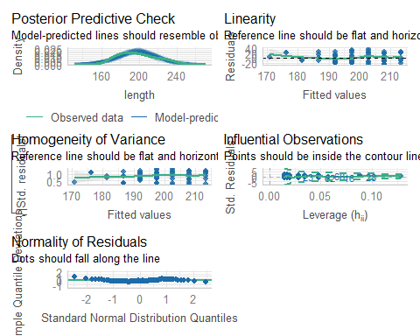
This function offers an alternative to the standard plots and provides an additional figure here called the “Posterior Predictive Check.” This plot uses the model you’ve fitted to simulate a range of datasets with boto lengths. The idea is that if the model is reasonable, it should be able to simulate data that closely resembles the original dataset.
An added benefit is that these plots come with guidance on what to look for in each diagnostic plot. However, remember that not all assumptions are equally important.

The Beetles
Having diagnosed the boto model, let’s move on to the beetle model from the last workshop. If you haven’t run that model yet, do so now. Once you have, go through the process of checking the model diagnostics to determine if you’re willing to place your trust in the model.

Question Set Two
- Do any of the diagnostic plots for the beetle model suggest a reason to not trust the results?
# The model has pretty clear non-linearity, and fitting a linear trend really messes up inference because the beetles have a thermal optimum at about 20 degrees. Too cold or too hot are equally bad and result in fewer offspring being produced. Basically, we're trying to fit a straight line through a hump. It just doesn't work.
# Load data
beetles <- read.table("H:/BI3010/Workshop3/beetles.txt", header = TRUE)
# EDA
summary(beetles)
ggplot(beetles) +
geom_point(aes(x = temperature, y = offspring)) +
theme_minimal()
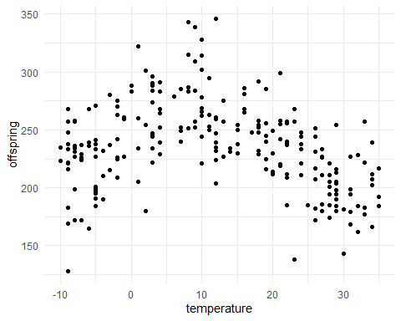
# Relationship looks non-linear
# Model fit
beetles_mod <- lm(offspring ~ temperature, data = beetles)
# Diagnostics
plot(beetles_mod)
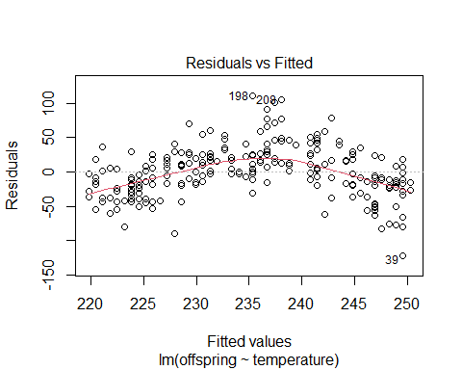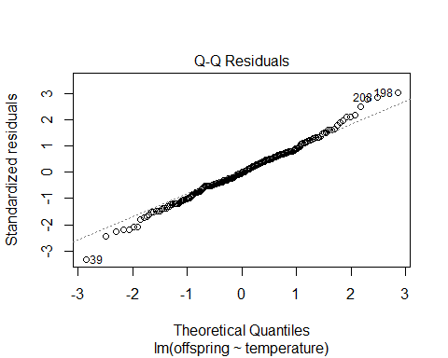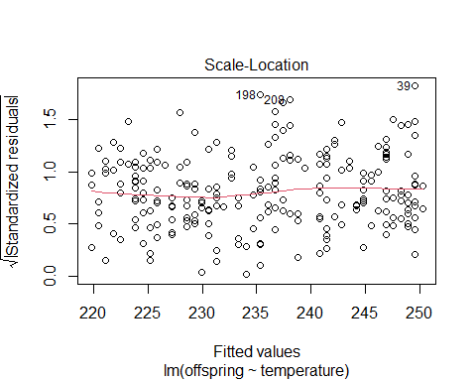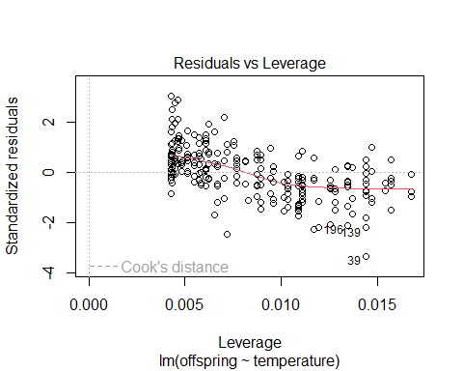
# Plot predictions (with raw data as points)
beetles$fit <- predict(beetles_mod)
ggplot(beetles) +
geom_point(aes(x = temperature, y = offspring)) +
geom_line(aes(x = temperature, y = fit)) +
labs(x = "Temperature",
y = "Offspring") +
theme_minimal()
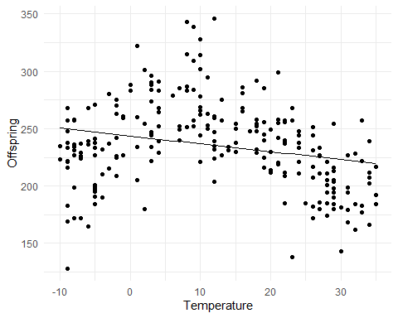

Assumption table
Assumption | Description | Example of Violation
1. Validity | The data is able to answer the research question effectively. | Using IQ to measure overall intelligence (what does IQ even measure?).
2. Representativeness | The data reflects the population or group being studied. | Using survey data from a rural area to draw conclusions about an urban population.
3. Additivity | Effects of predictors are additive and there are no interactions between them. | Assuming that study hours and sleep hours independently affect exam scores without considering their combined effect (imagine a Venn diagram with study and sleep overlapping).
4. Linearity | The relationship between predictors and the outcome is linear. | Assuming plant growth will continue to increase indefinitely without ever levelling out.
5. Independence of Errors | Observations are independent of each other. (Related to residual errors.) | If modelling height, the data come from the same group of children over time.
6. Equal Variance of Errors | Residuals have constant variance across all levels of predictors (“homoscedasticity”). (Related to residual errors.) | If modelling income, variability in salaries is not the same across all levels of a company’s hierarchy.
7. Normality of Errors | Residuals should be normally distributed. (Related to residual errors.) | If modelling income, the presence of any extremely wealthy individuals will be hard for the model to understand and explain.

